**CATARACT DETECTION AND GRADING USING CONVOLUTIONAL NEURAL NETWORK**

**Problem Statement:**

Cataract is one of the most common causes of permanent blindness in human beings. It is a cloudy area in the lens of the eye that leads to a gradual decrease in vision if left untreated.

Cataract is graded into 4 Grades (Grade I, Grade II, Grade III, Grade IV): Mild, Moderate, Pronounced, Severe.

My Aim is to investigate the performance of DCNN to detect and grade cataract automatically in this Project.

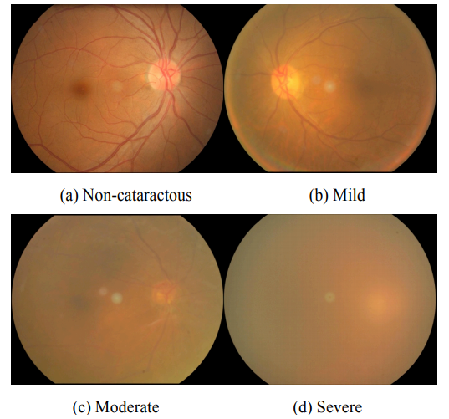

**Introduction:**

Previous studies have been conducted on fundus image analysis for years. Methods for cataract classification using Neural Networks consists of 4 parts: Pre-processing, Feature Extraction, Feature Selection and classifier.

The Final Accuracy of the detection and grading depends on the quality of images present in the dataset. The detection Accuracy of papers mentioned here are good but the grading part is a bit low due to lack of high quality images.

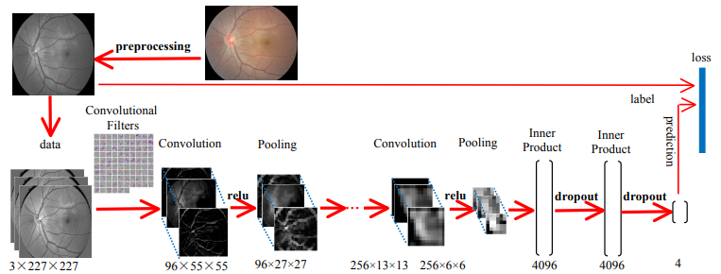

**Research Journals:**

1. Artificial Intelligence for Cataract Detection and Management Jocelyn Hui Lin, Zhi Wei Lim, BSc(Hons), Xiaoling Fang, MD, Ayesha Anees, MSc, Simon Nusinovici, PhD, Tyler Hyungtaek Rim, MD, PhD, Ching-Yu Cheng, MD, PhD, and Yih-Chung Tham, PhD
2. Automatic Cataract Detection And Grading Using Deep Convolutional Neural Network Linglin Zhanga , Jianqiang Lia , i Zhangb , He Hana , Bo Liua , Jijiang Yangc, Qing Wangc a School of Software Engineering, Beijing University of Technology, Beijing, China b Beijing Tongren Eye Center, Beijing Tongren Hospital, Capital Medical University, Beijing, China c Research Institute of Information Technology, Tsinghua University, Beijing, China.
3. Automatic Feature Learning to Grade Nuclear Cataracts Based on Deep Learning Xinting Gao, Member, IEEE, Stephen Lin, Member, IEEE, and Tien Yin Wong
4. Cataract Detection Using Convolutional Neural Network with VGG-19 Model.
5. CataractNet: An Automated Cataract Detection System Using Deep Learning for Fundus Images MASUM SHAH JUNAYED 1,2, MD BAHARUL ISLAM 1,2,3, (Senior Member, IEEE), AREZOO SADEGHZADEH 2, AND SAIMUNUR RAHMAN 4